STATISTICAL ARBITRAGE
Exploiting Transient Mispricings Through Quantitative, Market-Neutral Trading
From Pairs Trading to Multi-Factor, Portfolio-Scale Mean Reversion
A Level 2 module in the Quantitative Finance Curriculum
Covers: pairs trading · correlation vs. cointegration · the Ornstein-Uhlenbeck framework · z-score entry/exit rules · cross-sectional mean reversion · ETF & index arbitrage · merger arbitrage · risk management & execution · capacity, crowding, and the August 2007 quant quake

Table of Contents
How to Use This Guide
What You Need to Know Before Starting
Understand Before Proceeding
Why It Matters
How This Connects to the Rest of the Curriculum
Glossary of Recurring Terms
Part 1 — What Is Statistical Arbitrage?
1.1 The Core Idea: Relative Value and Mean Reversion
1.2 A Brief History: From Morgan Stanley's APT Desk to Today
1.3 The Statistical Arbitrage Pipeline
Part 2 — Pairs Trading: The Foundational Strategy
2.1 Finding Pairs: Correlation vs. Cointegration
2.2 The Distance Method and the Cointegration Method
2.3 Trading the Spread: Z-Scores, Entries, and Exits
Part 3 — From Pairs to Portfolios: Multivariate StatArb
3.1 The Ornstein-Uhlenbeck Model of Mean Reversion
3.2 Basket Trading and Cointegrated Portfolios
3.3 Factor-Neutral StatArb: Trading the Residual
Part 4 — Strategy Families in Statistical Arbitrage
4.1 Cross-Sectional Mean Reversion (Equity Market-Neutral)
4.2 ETF and Index Arbitrage
4.3 Merger Arbitrage and Event-Driven StatArb
4.4 Cross-Asset and Futures StatArb
Part 5 — Risk, Execution, and Practical Considerations
5.1 Risk Management: Stops, Sizing, and Correlation Breakdown
5.2 Transaction Costs, Capacity, and Execution
5.3 Pitfalls: Regime Change, Crowding, and the Quant Quake
Practical Exercise
Common Beginner Mistakes
Advanced Extensions
Professional Applications
Where to Go Next

How to Use This Guide
This document introduces Statistical Arbitrage (often shortened to StatArb), a family of quantitative trading strategies that seek to profit from small, temporary mispricings between related securities while remaining close to market-neutral — that is, largely insulated from the overall direction of the market. Where the Factor Models module asked "what systematic forces drive returns," this module asks a complementary question: "when two or more securities that should move together temporarily drift apart, how do you trade the gap, and how do you do it at scale, across hundreds or thousands of securities, in a disciplined and risk-controlled way?"
This module builds from the simplest possible statistical arbitrage trade — a single pair of stocks — up through the portfolio-scale, factor-neutral systems run by quantitative hedge funds today. Each section follows the same pattern: the intuition first, then the formal mathematics, then a worked numerical example, then a figure, and finally a discussion of where the idea is used in practice and where it can go wrong. Read the module start to finish for the complete picture, or use the Table of Contents to jump to a specific strategy family — but do not skip Understand Before Proceeding below.

What You Need to Know Before Starting
- Basic statistics — mean, variance, standard deviation, and correlation; z-scores and the normal distribution recur throughout every section of this module.
- Linear regression — ordinary least squares (OLS), residuals, and R²; the "spread" between two securities in a pairs trade is, in the simplest case, nothing more than a regression residual.
- Time series basics — the idea of a random walk versus a mean-reverting process; this module leans heavily on the distinction, formalized in Part 3 through the Ornstein-Uhlenbeck model.
- Factor Models (recommended, not required) — Part 3.3 of this module trades the residual left over after removing common factor exposures, which builds directly on the risk-decomposition ideas from that module.

Understand Before Proceeding
Prerequisite gate — Statistical arbitrage is a statement about historical statistical relationships, not a law of financial physics. Two securities that have moved together for five years can stop moving together permanently — because of a merger, a regulatory change, a change in one company's business, or simply because the historical relationship was a product of chance rather than genuine economic linkage. The single most common and most dangerous error made by newcomers to this material is treating a strong historical correlation or a statistically significant cointegration test as a guarantee that a spread will revert. It is not a guarantee; it is a probabilistic edge that must be sized, hedged, and monitored accordingly — and the difference between those two mental models is, more than any formula in this module, what separates a professional statistical arbitrage desk from an account that blows up the first time a "reliable" spread fails to revert.

Why It Matters
Statistical arbitrage matters for three interlocking reasons. First, it is one of the few major strategy families that is genuinely market-neutral by design: because every position is held alongside an offsetting position, a well-constructed StatArb portfolio can, in principle, make money whether the overall market rises, falls, or goes nowhere — which is very different from a directional strategy that simply hopes to be on the right side of the market's next move. Second, it is one of the clearest illustrations of how statistics becomes a trading edge: the entire strategy rests on being able to tell the difference between a relationship that is statistically real and one that merely looks real in a historical sample, which is exactly the kind of judgment this module is built to train. Third, statistical arbitrage is economically useful, not just profitable: by buying the relatively cheap security in a pair and selling the relatively expensive one, StatArb traders push prices back toward their historical relationship, which is precisely the mechanism by which markets are kept efficient — the strategy's profit is, in a real sense, a service fee for correcting a temporary mispricing.
It also matters because it is unforgiving of sloppy statistics in a way few other strategies are. A momentum or value strategy that is slightly mis-specified will usually just underperform; a poorly hedged statistical arbitrage position can lose money in both directions at once if the spread moves the wrong way while the position is also carrying unintended market or sector exposure. Learning to build and risk-manage a StatArb strategy properly is one of the most direct ways to build the underlying quantitative discipline this entire curriculum is trying to teach.

How This Connects to the Rest of the Curriculum
- Factor Models — Part 3.3 of this module trades the idiosyncratic residual left over after removing common factor exposures, using exactly the risk-decomposition machinery covered in that module's Part 4.
- Alpha Research — Statistical arbitrage is one of the canonical strategy families covered in the Alpha Research curriculum; this module supplies the statistical estimation techniques (cointegration, the Ornstein-Uhlenbeck model) that sit underneath a StatArb signal.
- Risk Metrics — The correlation-breakdown and drawdown risks covered in Part 5 of this module are a direct application of the portfolio risk measurement techniques covered in that module.
- Portfolio Construction & Execution — Because StatArb strategies trade in large numbers of small positions with tight margins, the execution-cost and capacity analysis in Part 5.2 connects directly to the portfolio-construction track's treatment of transaction costs and market impact.

Glossary of Recurring Terms
Statistical arbitrage (StatArb) — A family of quantitative trading strategies that take offsetting long and short positions in related securities, seeking to profit when a temporary divergence between them reverts toward its historical relationship.
Pairs trading — The simplest form of statistical arbitrage: going long one security and short another closely related security when the spread between them diverges from its historical norm, and closing both positions when it reverts.
Spread — The measured difference (or ratio, or regression residual) between two or more related securities' prices, whose fluctuation around a stable mean is what a statistical arbitrage strategy actually trades.
Market-neutral — A portfolio construction approach in which long and short positions are sized so that the portfolio's net exposure to the overall market (and often to other common factors) is approximately zero.
Correlation — A measure of how closely two return series move together, ranging from -1 to +1; correlation describes co-movement over a sample but says nothing on its own about whether prices remain tied together in the long run.
Cointegration — A statistical property in which two or more non-stationary price series can be combined, in fixed proportions, into a new series that is stationary — that is, that reverts to a stable mean — even though the individual prices themselves wander without bound.
Stationarity — A property of a time series whose statistical characteristics (mean, variance) do not change over time; a stationary spread is one that fluctuates around a constant long-run mean rather than drifting indefinitely.
Z-score — The number of standard deviations a current observation lies from its historical mean, used throughout this module to decide when a spread has diverged far enough to trade and when it has reverted far enough to exit.
Ornstein-Uhlenbeck (OU) process — A continuous-time stochastic process that mean-reverts toward a long-run level at a speed governed by a single parameter, used as the standard mathematical model for a tradeable spread.
Half-life — The expected time for a mean-reverting spread to close half the distance back to its long-run mean, derived directly from the OU process's mean-reversion speed.
Distance method — A simple, non-parametric way of selecting pairs by minimizing the sum of squared differences between two normalized price series over a historical formation period.
Cross-sectional mean reversion — A statistical arbitrage approach applied across an entire universe of stocks at once, ranking stocks by recent relative performance and betting that recent relative winners will underperform recent relative losers over the short term.
ETF arbitrage — A statistical arbitrage strategy that trades the spread between an exchange-traded fund and the basket of underlying securities (or futures) it is designed to track.
Merger arbitrage — An event-driven strategy that trades the spread between a target company's stock price and the announced acquisition price, betting on the probability the deal closes.
Beta-neutral / dollar-neutral — Two related but distinct portfolio construction rules: dollar-neutral means the dollar value of longs equals the dollar value of shorts; beta-neutral means the portfolio's weighted-average market beta is zero, which typically requires unequal dollar amounts if the long and short legs have different betas.
Alpha decay — The tendency of a strategy's predictive signal to weaken over the holding period, and more broadly the tendency of a strategy's profitability to shrink as more capital chases the same signal or as market conditions change.
Crowding — The condition in which a large amount of capital is positioned in economically similar statistical arbitrage trades, raising the risk that many participants are forced to unwind at the same time.
Quant quake — The nickname for the severe, highly correlated losses suffered by numerous quantitative equity funds in early-to-mid August 2007, widely attributed to a large, rapid deleveraging that forced correlated selling across similar statistical arbitrage and factor strategies.

Part 1 — What Is Statistical Arbitrage?
Part 1 introduces the core intuition behind statistical arbitrage, traces its history from a single proprietary trading desk in the 1980s to a strategy family run by funds managing hundreds of billions of dollars today, and lays out the general pipeline that every statistical arbitrage strategy in this module follows, however different the details.

1.1 The Core Idea: Relative Value and Mean Reversion
Most trading strategies make a directional bet: will this stock go up or down? Statistical arbitrage asks a different, narrower question: will the relationship between two or more related securities move back toward its historical norm? Consider two large, similar companies in the same industry — say, two national beverage makers. Their stock prices will not move in lockstep every single day, but over long periods their prices tend to drift together, because they are exposed to much of the same industry-wide news, the same commodity input costs, and many of the same macroeconomic forces. If, on some particular day, one company's stock jumps 4% on no company-specific news while the other barely moves, a statistical arbitrage trader does not try to guess which direction the market is heading — they simply bet that the unusual gap between the two stocks will narrow again, by shorting the stock that moved up and buying the stock that did not.
This is the defining feature of the entire strategy family: a statistical arbitrage position is built from two or more legs, structured so that a very large share of the ordinary, everyday market risk that both legs share cancels out, leaving a position whose profit and loss is driven almost entirely by the narrower relative movement between the securities — the spread — rather than by which way the market as a whole happens to move. Because that spread has, historically, fluctuated around a stable long-run relationship rather than drifting off indefinitely, betting on its return to that relationship is a mean-reversion bet, and mean reversion is the statistical property that every strategy in this module is ultimately trying to identify and trade.
Tip — It is easy to conflate "market-neutral" with "risk-free." A statistical arbitrage position removes exposure to the overall market's direction, but it does not remove exposure to the spread itself failing to revert, to sudden liquidity shocks, or to the position needing to be unwound at an inopportune moment. "Market-neutral" describes what kind of risk a StatArb position is exposed to, not how much risk it carries.

1.2 A Brief History: From Morgan Stanley's APT Desk to Today
Statistical arbitrage in its modern form is generally traced to a proprietary trading group at Morgan Stanley in the mid-1980s, associated with quantitative researchers including Gerry Bamberger and later Nunzio Tartaglia, who built systematic pairs-trading strategies using historical price relationships between similar stocks. The core insight — automate the search for temporarily diverged, historically related securities, and trade the reversion systematically and at scale rather than relying on a single trader's judgment about a single pair — proved highly profitable in its early years and spread rapidly to other Wall Street desks and, soon after, to dedicated hedge funds through the 1990s and 2000s.
The strategy family has evolved substantially since those early single-pair trades. Renaissance Technologies, D.E. Shaw, and a wave of other quantitative funds extended the core idea from simple pairs to large baskets of hundreds or thousands of securities, from raw price relationships to relationships defined after removing common factor exposures, and from daily rebalancing to holding periods measured in minutes. The core logic, however, has remained remarkably stable across four decades: find securities whose relationship is statistically well-behaved, trade the deviation from that relationship, and size the trade so that unrelated sources of risk are hedged away as completely as possible.

1.3 The Statistical Arbitrage Pipeline
Every strategy covered in this module — however different its specific securities, holding period, or mathematics — follows the same general pipeline, which is worth internalizing before the details of any individual strategy family:
- Universe selection — Define the set of securities eligible for pairing or basket construction (a sector, an index, an asset class, a set of related futures contracts).
- Relationship discovery — Identify which securities, or which linear combinations of securities, exhibit a statistically stable, mean-reverting relationship (Parts 2 and 3 cover this in depth).
- Signal construction — Convert the current deviation from that relationship into a standardized trading signal, typically a z-score.
- Position sizing and hedging — Size the long and short legs so that unwanted exposures (market beta, sector, other common factors) are neutralized as far as practical.
- Execution — Enter and exit positions efficiently, minimizing the transaction costs and market impact that can easily erode a strategy whose individual trade edge is often quite small (Part 5.2).
- Risk management and monitoring — Continuously test whether the underlying statistical relationship still holds, and cut a position, or a pair, loose if it has broken down rather than reverted (Part 5.1).
Parts 2 through 4 of this module work through this pipeline for progressively more sophisticated strategy designs — a single pair, then a portfolio of pairs and baskets, then factor-neutral and cross-sectional approaches, then the specific strategy families used across equities, ETFs, event-driven situations, and other asset classes. Part 5 returns to the risk-management and execution stages that apply across all of them.

Part 2 — Pairs Trading: The Foundational Strategy
Part 2 works through the original and still most intuitive statistical arbitrage strategy in full detail: how to find a tradeable pair, how to define and measure the spread between them, and how to turn that spread into a disciplined set of entry and exit rules.

2.1 Finding Pairs: Correlation vs. Cointegration
The first step in any pairs trade is finding two securities whose prices are linked closely enough that a divergence between them is likely to be temporary rather than the start of a permanent split. The most intuitive starting point — and the most common beginner mistake — is simply to look for a high historical correlation between the two securities' returns. Correlation is easy to compute and easy to understand, but it measures only whether two series tend to move in the same direction on the same day; it says nothing about whether the price levels of the two securities stay tied together over the long run.
This distinction matters enormously in practice. Two stocks can be highly correlated in their day-to-day returns while their price levels drift arbitrarily far apart over time — for example, if one company simply grows faster than the other for structural reasons unrelated to any temporary mispricing. A pairs trade built purely on correlation can therefore short a stock that is genuinely becoming more valuable relative to its partner, with no reversion ever arriving. The statistically correct property to look for instead is cointegration: the existence of a linear combination of the two (non-stationary, individually wandering) price series that is itself stationary — that reverts to a stable mean rather than drifting.
Spread_t = log(Pᴬ,t) − β · log(Pᴮ,t) (the spread is stationary if A and B are cointegrated)
Here β (the hedge ratio) is estimated by regressing the log-price of security A on the log-price of security B, and cointegration is tested formally by checking whether the resulting residual series is stationary — most commonly using the Engle-Granger two-step method or the Augmented Dickey-Fuller (ADF) test applied to the residual. A statistically significant test result is evidence, though never proof, that the two securities share a genuine, tradeable long-run relationship rather than a coincidental period of similar returns.
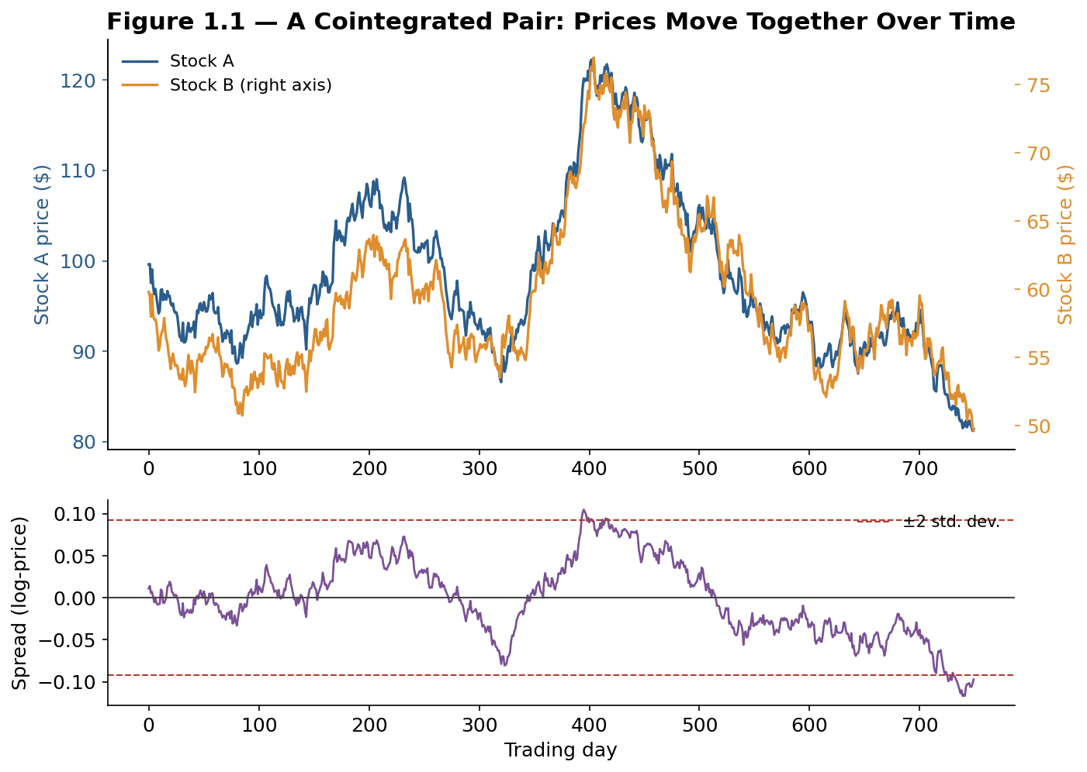
Figure 1.1 — A cointegrated pair: two stock prices track each other closely over time (top panel), leaving a stationary spread that oscillates around a stable mean within a fairly consistent band (bottom panel).
Common mistake — Selecting pairs on correlation alone, without testing for cointegration. It is entirely possible — and, given how many candidate pairs are typically screened, statistically likely to happen by chance for at least a few pairs — to find two stocks with 0.9+ return correlation whose prices are not cointegrated at all, because both simply trended upward together over the sample period for unrelated reasons. Always test the spread itself for stationarity before trading it; a high correlation is a reasonable first screen, never a final answer.

2.2 The Distance Method and the Cointegration Method
Two approaches dominate how pairs are actually selected in practice, and they involve a real trade-off between simplicity and statistical rigor.
- The distance method — Normalize both securities' prices to a common starting point (for example, indexing both to 100 at the start of the formation period) and select the pair that minimizes the sum of squared differences between the two normalized series. This approach, popularized in the academic literature by Gatev, Goetzmann, and Rouwenhorst, is simple, fast to compute across thousands of candidate pairs, and makes no distributional assumptions — but it implicitly assumes a 1-to-1 hedge ratio and provides no formal statistical test of whether the resulting spread is actually mean-reverting.
- The cointegration method — Explicitly estimate the hedge ratio β via regression and test the resulting residual for stationarity, as described in 2.1. This approach is more statistically rigorous, allows for hedge ratios other than 1-to-1, and provides a formal significance test — at the cost of being more computationally intensive and requiring more careful handling of the statistical assumptions underlying the cointegration test itself.
Approach | Hedge ratio | Statistical rigor | Computational cost | Common use case
Distance method | Fixed at 1-to-1 | Low — no formal test | Low — fast to screen | Rapid screening of large universes
Cointegration method | Estimated via regression | High — formal ADF/Engle-Granger test | Higher — regression + test per pair | Production pair selection
In practice, many desks use the distance method as a fast first-pass filter across a large universe of candidate pairs, and then apply the more rigorous cointegration test only to the shortlist of pairs that survive that first screen — combining the speed of the simple method with the statistical discipline of the more rigorous one.

2.3 Trading the Spread: Z-Scores, Entries, and Exits
Once a tradeable spread has been identified, it is converted into a standardized trading signal by computing its z-score — how many standard deviations the current spread sits from its historical mean:
z_t = (Spread_t − μ) / σ (μ and σ estimated over a rolling historical lookback window)
A simple, widely used rule structure trades this z-score directly: enter a position when the z-score crosses a threshold in either direction, and exit when it reverts back toward zero.
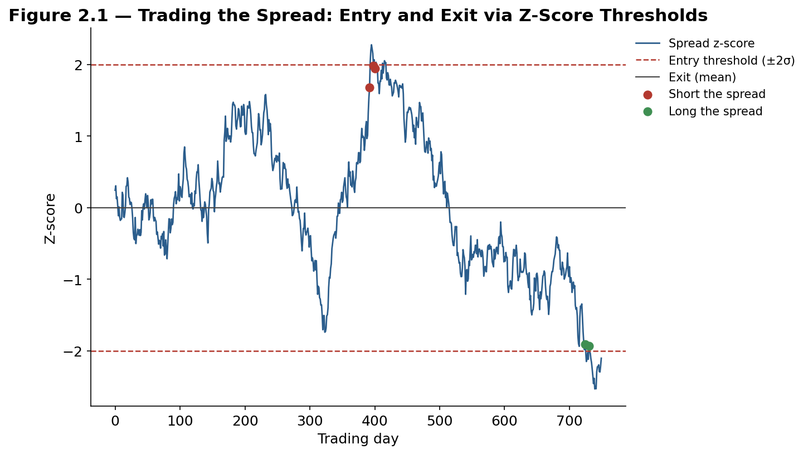
Figure 2.1 — Trading the spread: a short-the-spread signal fires when the z-score rises above +2 (sell the richer leg, buy the cheaper leg), and a long-the-spread signal fires when it falls below −2; both positions are closed as the z-score reverts toward zero.
Worked example — Suppose a pair's spread has a historical mean of 0 and a standard deviation of 1.5 (in log-price terms). On a given day the spread reads 3.4, giving a z-score of 3.4 / 1.5 ≈ 2.27 — above a +2 entry threshold. The strategy shorts security A and buys security B in the hedge-ratio proportion β, sized so the position is dollar- or beta-neutral. Over the following days the spread narrows back toward 0; once the z-score crosses back below roughly 0.3 (near the mean, allowing some buffer to avoid excessive round-trip trading right at zero), the position is closed and the captured spread narrowing is realized as profit, largely independent of whether the overall market rose or fell over the same days.

Three practical parameters govern how this simple rule actually performs, and each involves a genuine trade-off:
- Lookback window for μ and σ — A longer window gives a more statistically stable estimate of the spread's "normal" range but adapts more slowly if the true relationship has shifted; a shorter window adapts quickly but produces noisier, less reliable entry and exit levels.
- Entry threshold — A wider threshold (say, ±2.5σ instead of ±2σ) trades less often but on more extreme, arguably higher-conviction divergences; a narrower threshold trades more often, capturing more opportunities at the cost of more false signals and more transaction costs.
- Exit rule — Exiting exactly at the mean (z = 0) maximizes the captured reversion per trade but risks missing the exit if the spread overshoots back through zero quickly; exiting at a small buffer around zero, or after a maximum holding period, trades off some potential profit for more robust, lower-turnover execution.
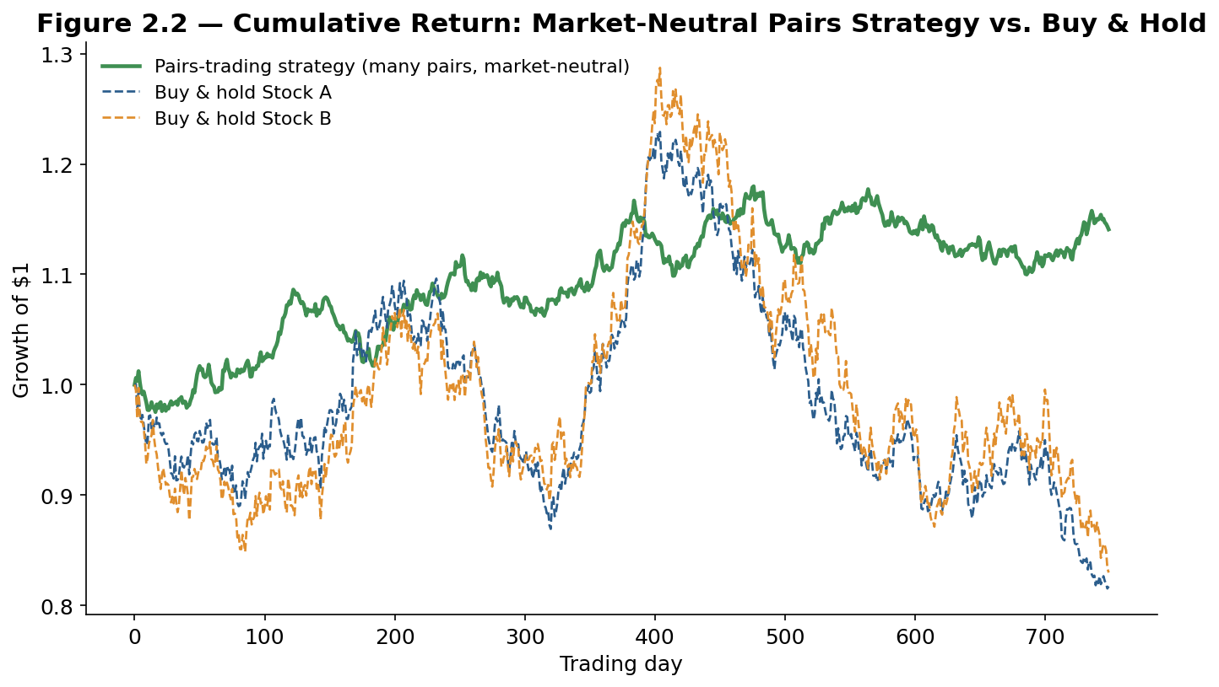
Figure 2.2 — A diversified pairs-trading strategy (many pairs traded simultaneously) produces a comparatively steady, low-volatility equity curve, in contrast to the far more volatile buy-and-hold paths of the two individual stocks it is built from — the visual signature of a market-neutral strategy.

Part 3 — From Pairs to Portfolios: Multivariate StatArb
A single pair is a useful teaching example, but no professional statistical arbitrage desk runs its business on one pair. Part 3 introduces the mathematical model that underlies every mean-reverting spread in this module, then generalizes from a single pair to baskets of securities and, finally, to trading the residual left over after removing common factor exposures — the form in which most institutional statistical arbitrage is actually run today.

3.1 The Ornstein-Uhlenbeck Model of Mean Reversion
The standard mathematical model for a mean-reverting spread is the Ornstein-Uhlenbeck (OU) process, a continuous-time stochastic process originally developed in physics to describe the velocity of a particle under friction, and adopted in finance because it captures exactly the behavior a tradeable spread should exhibit: it wanders randomly in the short run but is continuously pulled back toward a long-run mean.
dXₜ = θ(μ − Xₜ) dt + σ dWₜ
Here Xₜ is the spread at time t, μ is its long-run mean, θ ("theta") is the speed of mean reversion, σ is the volatility of the random shocks, and dWₜ is a standard Brownian motion term representing unpredictable noise. The larger θ is, the faster the spread is pulled back toward μ after any deviation; as θ approaches zero, the process behaves increasingly like a plain random walk with no meaningful mean reversion at all — which is exactly the failure mode a cointegration test in Part 2.1 is designed to rule out before a pair is ever traded.
Half-life = ln(2) / θ
The half-life derived from θ is one of the most practically important numbers in the entire strategy: it is the expected number of periods for a deviation to close half the distance back to the mean, and it directly informs both the expected holding period of a trade and the choice of lookback window used to estimate the spread's mean and standard deviation in the first place.
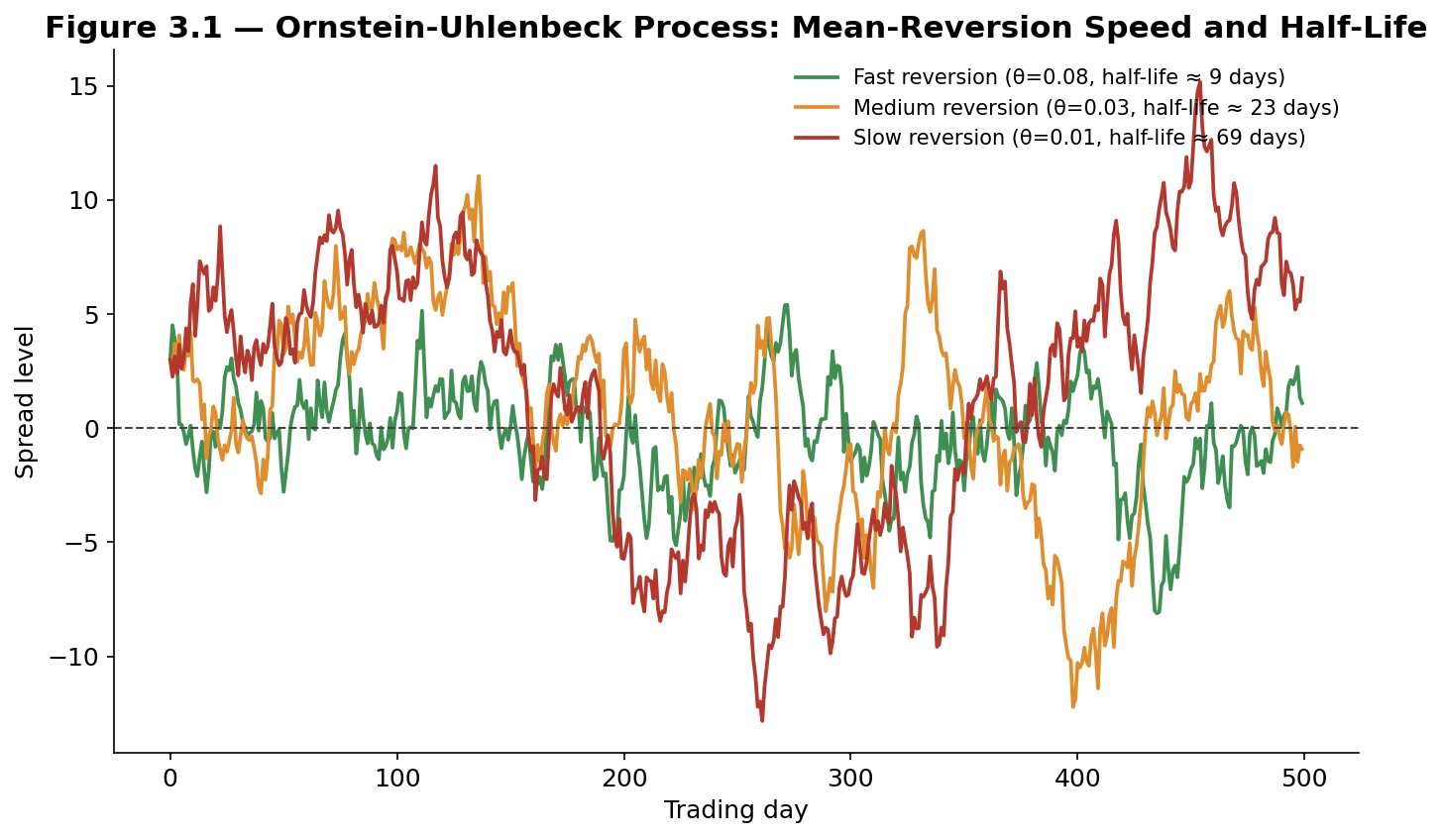
Figure 3.1 — Three simulated Ornstein-Uhlenbeck paths with different mean-reversion speeds: a fast-reverting spread (large θ) stays tightly clustered near its mean with a short half-life, while a slow-reverting spread (small θ) wanders much further before reverting, exhibiting a much longer half-life and, correspondingly, more random-walk-like behavior in the short run.
Tip — A very short half-life (a few days) suggests a spread that reverts quickly but may also be dominated by market microstructure noise and transaction costs rather than a genuine tradeable relationship; a very long half-life (many months) suggests a real but slow-moving relationship that ties up capital for a long time per unit of realized profit. Most practical statistical arbitrage strategies target spreads with half-lives somewhere in the range of a few days to a few weeks, a range short enough to trade often but long enough to be economically distinguishable from noise.

3.2 Basket Trading and Cointegrated Portfolios
The two-security pair generalizes naturally to a basket: a portfolio of more than two securities, combined in fixed weights, whose weighted combination is stationary even though no two individual securities in the basket need be cointegrated with each other on their own. A classic example is trading a single oil-producing company against a weighted basket of the broad energy sector, or trading one airline against a basket of several competitor airlines weighted by their relative sensitivity to fuel costs and travel demand, rather than searching for one single "best" competitor to pair it against.
Spread_t = Σᵢ wᵢ · log(Pᵢ,t) (basket weights wᵢ chosen so the combination is stationary)
Basket construction is typically done via cointegrating regression (regressing one security on several others simultaneously and testing the residual for stationarity, generalizing the two-security Engle-Granger approach) or via more advanced multivariate techniques such as the Johansen test, which can identify multiple independent cointegrating relationships within a single group of securities at once — useful when, for example, an entire sector contains more than one genuinely distinct mean-reverting sub-relationship.
Trading baskets rather than single pairs offers a meaningful diversification benefit: with more, less mutually correlated spreads running simultaneously, the idiosyncratic noise in any single spread's short-term behavior averages out across the portfolio, smoothing the overall equity curve and improving the realized Sharpe ratio, even if no individual spread's own risk-reward improves at all.
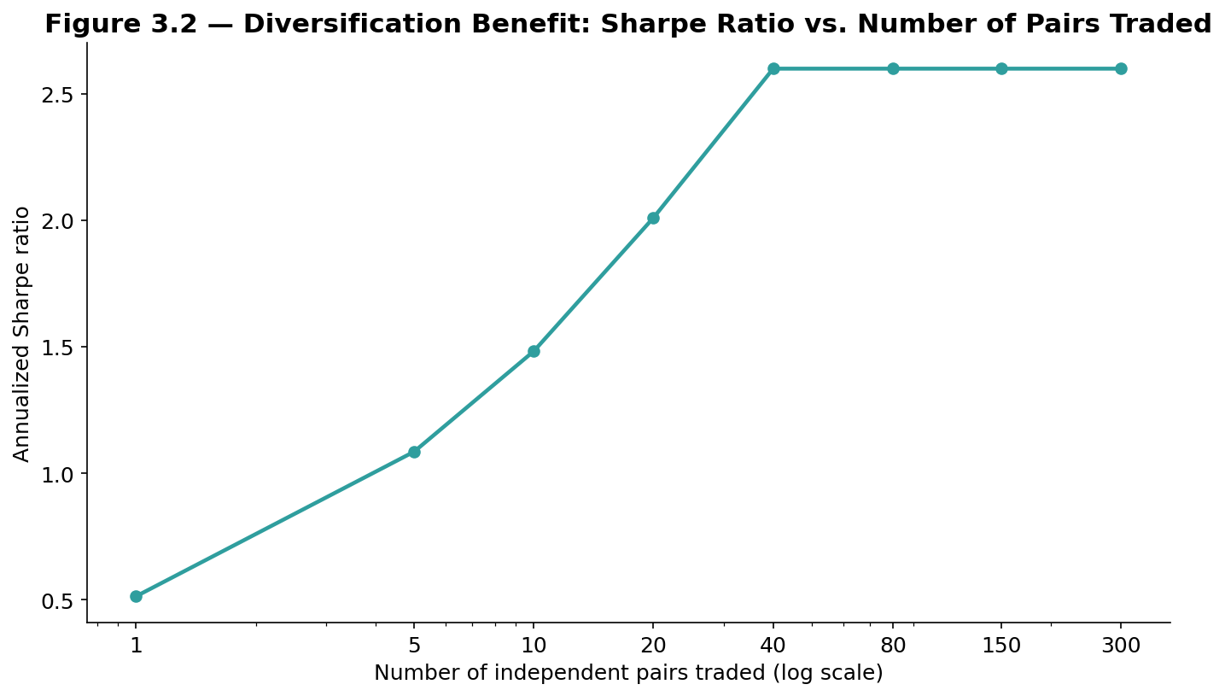
Figure 3.2 — The diversification benefit of trading many largely independent pairs or baskets simultaneously: Sharpe ratio rises steeply as the number of positions increases from a handful to several dozen, then flattens out as the marginal benefit of each additional, increasingly similar position diminishes.
Worked example — A single well-chosen pair might realistically run at an annualized Sharpe ratio of roughly 0.5, reflecting a real but noisy edge. Running 40 largely independent pairs simultaneously, each with a similar individual Sharpe ratio, can push the combined portfolio's Sharpe ratio toward 2.0 or higher, purely through diversification — the same underlying statistical logic that makes a diversified stock portfolio less risky than any single stock within it, applied here to a portfolio of independent spread bets rather than a portfolio of individual securities.

3.3 Factor-Neutral StatArb: Trading the Residual
The most institutionally significant generalization of pairs trading replaces the simple two-security spread with the residual return left over after removing a stock's exposure to a full factor model — exactly the market, size, value, momentum, and other factors covered in the Factor Models module's Part 3. Instead of pairing one stock against one competitor, a factor-neutral StatArb strategy regresses every stock in a large universe against a common set of factors, and trades the leftover, stock-specific residual as though it were a spread that should mean-revert.
εᵢ,t = Rᵢ,t − (αᵢ + βᵢ,1 F1,t + βᵢ,2 F2,t + ... + βᵢ,K FK,t) (the tradeable residual)
This approach has a major practical advantage over simple pairs trading: because the entire universe's common, systematic risk has already been explained away by the factor model, the leftover residual εᵢ,t for each stock should, in a well-specified model, be far closer to pure idiosyncratic noise — and short-term idiosyncratic mispricings, caused by temporary order-flow imbalances, index-rebalancing flows, or overreaction to stock-specific news, tend to revert considerably faster and more reliably than raw, unadjusted price relationships between two arbitrarily chosen stocks. A portfolio built to be long the stocks with the most negative recent residuals and short the stocks with the most positive recent residuals is, by construction, close to neutral with respect to every factor already included in the model — which is why this approach is often described as factor-neutral or residual statistical arbitrage, and is the form in which the strategy is most commonly run at scale by quantitative equity funds today.
Tip — The quality of a factor-neutral StatArb strategy depends directly on the quality of the underlying factor model. If the factor model is incomplete — missing a real, common driver of returns — some of what looks like tradeable idiosyncratic residual is actually unremoved systematic risk, and the resulting "market-neutral" portfolio may carry hidden factor exposures that only become visible during a period when that missing factor moves sharply.

Part 4 — Strategy Families in Statistical Arbitrage
Part 4 surveys the major strategy families that fall under the statistical arbitrage umbrella in practice. Each shares the core market-neutral, mean-reversion logic of Parts 1 through 3, applied to a different set of securities and, in some cases, a different underlying economic mechanism.

4.1 Cross-Sectional Mean Reversion (Equity Market-Neutral)
Rather than identifying individual pairs, a cross-sectional mean reversion strategy ranks every stock in a broad universe by its very recent relative performance — commonly its return over the previous one to five trading days — and takes a systematic position: short the recent relative winners, long the recent relative losers, rebalanced daily or even more frequently. The underlying economic driver is generally attributed to short-term liquidity effects — large trades and order-flow imbalances temporarily push a stock's price away from its fair value, and that price impact fades over the following one to a few days as liquidity providers and other market participants absorb the imbalance.
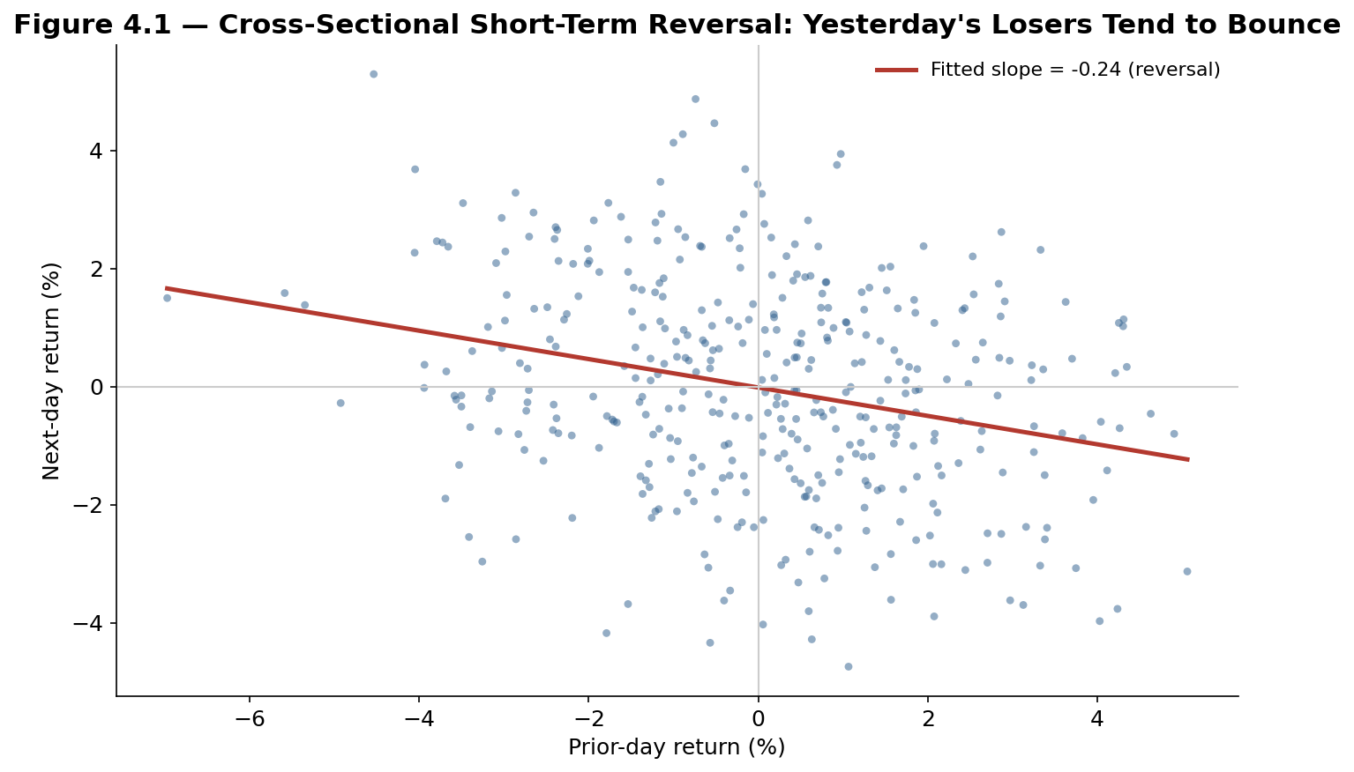
Figure 4.1 — Cross-sectional short-term reversal in a simulated universe: stocks with the largest prior-day gains tend to give some of it back the next day, and stocks with the largest prior-day losses tend to partially bounce, producing a clear negative relationship between consecutive daily returns across the cross-section.
This strategy family is distinct from pairs trading in an important structural way: it makes no claim that any specific two stocks are economically linked. Instead, it relies on the statistical regularity that, averaged across a large cross-section of stocks and a large number of days, recent relative losers modestly outperform recent relative winners over the very short term. Because the effect is small per stock and decays quickly, it is typically implemented across hundreds or thousands of positions simultaneously, with very high turnover, and is unusually sensitive to transaction costs — a topic returned to in Part 5.2.

4.2 ETF and Index Arbitrage
An exchange-traded fund (ETF) is, by construction, supposed to track the value of an underlying basket of securities or a published index. Because ETF shares and the underlying basket both trade continuously, small discrepancies can open up between the ETF's market price and the aggregate value of its underlying holdings — the ETF's net asset value (NAV). ETF arbitrage trades this discrepancy directly: buying the ETF and shorting the underlying basket (or the reverse) whenever the ETF trades at a meaningful premium or discount to its NAV, capturing the gap as the two converge.
A closely related strategy, index arbitrage, trades the spread between a stock index (such as the S&P 500) and index futures contracts written on it, exploiting the fact that the futures price and the fair-value relationship implied by the spot index, the risk-free rate, and expected dividends must converge by the futures contract's expiration. Both strategies are considerably more mechanical and structurally-grounded than pairs trading between two arbitrarily related stocks — the underlying and the derivative are, by contractual design, supposed to converge — but both have also become intensely competitive, low-margin businesses dominated by high-speed market makers, because the mispricing is simple enough for many well-capitalized participants to detect and trade simultaneously.
Worked example — An ETF holding a basket of 500 stocks trades at $410.15 while the aggregate value of its underlying holdings, computed in real time, is $409.80 — a premium of roughly 9 basis points. An authorized participant (or an arbitrage desk with similar access) can short the ETF and buy the underlying basket, locking in the spread, and can also create new ETF shares by delivering the underlying basket to the fund sponsor in exchange for new shares, a structural mechanism unique to the ETF creation/redemption process that keeps this kind of premium or discount tightly bounded in liquid, well-arbitraged ETFs.

4.3 Merger Arbitrage and Event-Driven StatArb
Merger arbitrage (sometimes called risk arbitrage) trades the spread between a target company's current stock price and the price a acquirer has announced it will pay, betting on the probability the deal actually closes. When a merger is announced, the target's stock typically jumps toward, but not fully to, the announced deal price — the remaining gap reflects the market's assessment of deal risk (regulatory approval, financing risk, shareholder approval, the possibility of a competing bid) and the time value of money until the deal is expected to close. A merger arbitrage trader buys the target's stock (and, in a stock-for-stock deal, shorts the acquirer's stock in the announced exchange ratio) to capture that remaining spread if the deal closes as announced.
Annualized spread ≈ [(Deal price − Current price) / Current price] × (365 / Days to expected close)
Merger arbitrage is classified within the statistical arbitrage family because it shares the same core structure — a spread between two related prices that is expected to converge, captured with a largely market-neutral position — but it differs in an important respect from the strategies covered in Parts 2 and 3: the convergence is driven by a specific, identifiable corporate event with a binary outcome (the deal closes or it does not) rather than by a statistical tendency to revert to a long-run historical average. This makes the risk profile of merger arbitrage distinctly different — losses tend to be infrequent but severe (a deal breaking typically causes the target's stock to fall sharply), in contrast to the more continuous, gradually-varying risk of a classic mean-reverting spread.

4.4 Cross-Asset and Futures StatArb
The same core logic extends well beyond single-country equities. Calendar spread arbitrage trades the relationship between futures contracts on the same underlying asset but with different expiration dates, which are linked by the cost of carrying the underlying asset (storage costs, financing costs, and expected yield) between the two dates; a spread that trades away from its theoretical fair-value relationship is traded back toward it. Cross-exchange arbitrage trades the same or economically equivalent instrument listed on two different exchanges or in two different currencies, exploiting temporary price discrepancies that arise from segmented liquidity pools. Fixed-income statistical arbitrage applies the same cointegration and mean-reversion logic to yield curves and credit spreads, trading the relationship between bonds of different maturities or different issuers whose yields have historically moved together.
Across every one of these variations, the underlying pipeline from Part 1.3 remains identical: identify a statistically or contractually grounded relationship, measure the current deviation from it, size a hedged position that captures the deviation while minimizing unrelated exposures, and manage the risk that the relationship fails to converge as expected.

Part 5 — Risk, Execution, and Practical Considerations
The final part turns from strategy design to the practical discipline of running a statistical arbitrage portfolio: managing the risk that a spread does not revert, controlling the transaction costs that can quietly erode a strategy's edge, and understanding the crowding and regime-change risks that have produced the strategy family's most severe historical losses.

5.1 Risk Management: Stops, Sizing, and Correlation Breakdown
The central risk in any statistical arbitrage position is that the historical relationship it is built on breaks down rather than reverts — a risk that no amount of statistical rigor at the pair-selection stage can fully eliminate, since every cointegration test is estimated on a finite historical sample and every relationship can, in principle, change going forward. Professional risk management addresses this with several overlapping layers of discipline:
- Stop-losses on the spread itself — Closing a position if the z-score moves substantially beyond the entry threshold (for example, exiting if a position entered at a −2σ z-score continues to a −4σ z-score) rather than averaging down indefinitely on the assumption that reversion is merely delayed.
- Maximum holding periods — Closing a position automatically if it has not reverted within some multiple of the spread's estimated half-life, on the logic that a spread taking dramatically longer than its historical half-life to revert is itself evidence the underlying relationship may have shifted.
- Rolling re-validation of the relationship — Periodically re-testing cointegration (or re-estimating factor exposures, for a factor-neutral strategy) on a rolling basis, and removing pairs or securities whose statistical relationship has weakened below a chosen confidence threshold, rather than assuming a relationship validated once remains valid indefinitely.
- Position and portfolio-level limits — Capping the capital allocated to any single pair or basket, and monitoring the aggregate correlation across all open positions, since many individually small, well-hedged positions can still combine into a large, correlated bet if too many of them share an underlying economic driver.
Common mistake — Treating a wider-than-usual spread as a stronger buy signal without limit. A spread at −3σ is not necessarily a better trade than a spread at −2σ — it may simply mean the underlying relationship has already begun to break down, and continuing to add to the position on the assumption that a bigger deviation guarantees a bigger reversion is precisely the reasoning that has caused some of the largest realized losses in statistical arbitrage history. A disciplined stop-loss rule exists specifically to override this intuitive but dangerous impulse.

5.2 Transaction Costs, Capacity, and Execution
Statistical arbitrage strategies typically target small, per-trade edges captured across a very large number of positions and, often, a high rate of turnover — which makes them unusually sensitive to transaction costs relative to strategies that trade less frequently for a larger edge per trade. Bid-ask spreads, commissions, and — critically at larger scale — the strategy's own market impact (the tendency of a large order to move the price against the trader while it is being executed) can consume a meaningful share of a strategy's theoretical, frictionless return.
This directly produces the capacity constraint that limits how much capital any single statistical arbitrage strategy can profitably deploy: as assets under management grow, position sizes must grow with them, market impact rises accordingly, and the strategy's net return after costs shrinks — often substantially — even though the underlying statistical edge has not changed at all.
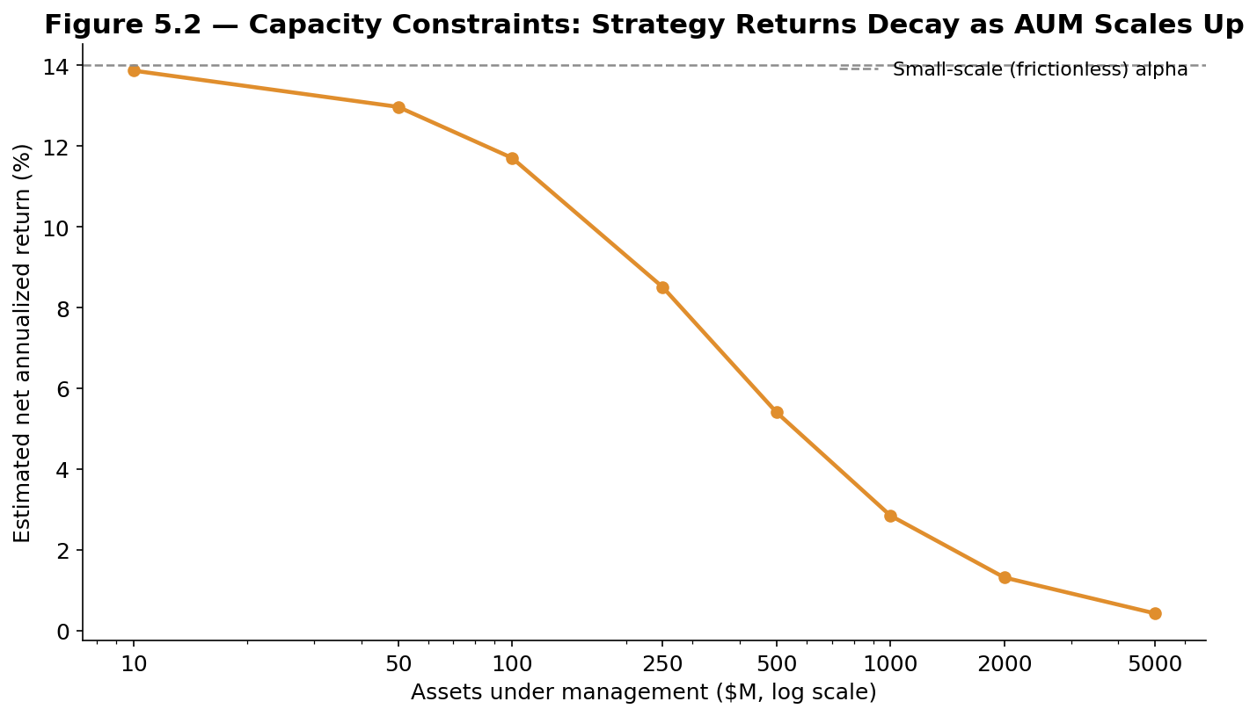
Figure 5.2 — A stylized illustration of capacity decay: a strategy's small-scale, near-frictionless return erodes steadily as assets under management increase, because larger positions incur proportionally greater market impact and execution cost.
Tip — Because capacity decay is smooth and predictable rather than a sudden cliff, professional statistical arbitrage funds routinely close their strategies to new capital well before returns have compressed to zero, preserving profitability for existing capital rather than chasing growth that would degrade returns for everyone invested in the strategy — one of the more distinctive business dynamics of the statistical arbitrage industry relative to strategies with less sharply diminishing capacity.

5.3 Pitfalls: Regime Change, Crowding, and the Quant Quake
Three related risks account for the majority of the statistical arbitrage industry's most severe historical drawdowns, and understanding them is essential context for anyone building or evaluating a StatArb strategy.
- Regime change — A relationship that was genuinely stable for years can permanently break — a merger removes one leg of a pair entirely, a change in a company's business model decouples it from its historical peer group, or a broad shift in market structure (algorithmic trading volume, changed regulation) alters the speed or reliability of reversion across an entire strategy family at once.
- Crowding — As more capital is deployed to capture similar statistical relationships — particularly in cross-sectional mean reversion, where many funds run economically similar strategies on overlapping universes — positions across different funds become correlated with each other even though each fund believes its own book is diversified and market-neutral, raising the risk that many participants are forced to unwind simultaneously.
- The August 2007 "quant quake" — The canonical historical example of both risks materializing at once: over roughly the first two weeks of August 2007, numerous quantitative equity funds running economically similar statistical arbitrage and factor-based strategies suffered severe, highly correlated losses over just a few trading days, widely attributed to one or more large, similarly-positioned funds deleveraging rapidly (reportedly to meet unrelated liquidity needs elsewhere in their business), which forced correlated selling across the whole crowded trade. Strategies with no fundamental problems and no company-specific bad news suffered losses of several percent in a matter of days, followed in several documented cases by a meaningful partial recovery once the forced selling subsided — a pattern consistent with a liquidity-driven crowding event rather than a genuine breakdown in the underlying statistical relationships.
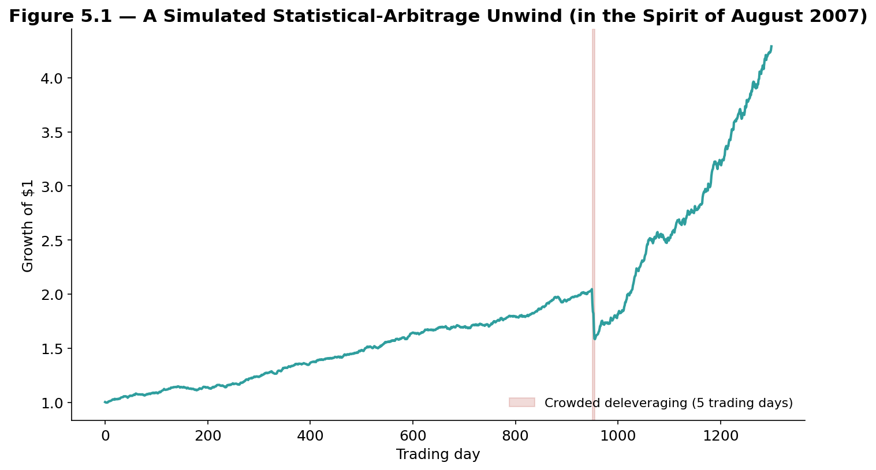
Figure 5.1 — A simulated illustration of a crowded statistical arbitrage unwind: a steady, low-volatility return pattern gives way to a sharp, multi-day loss as correlated deleveraging forces many similarly-positioned participants to exit at once, before the strategy resumes its normal pattern of returns.
The lasting lesson of the quant quake, still cited across the industry today, is that a portfolio can be genuinely market-neutral with respect to the overall stock market while still being highly exposed to a very specific, narrower risk: the risk that other similarly-positioned participants are forced to sell the same positions at the same time. This risk is largely invisible in a standard factor-model risk decomposition of the kind covered in the Factor Models module, because it is a statement about who else holds similar positions, not about any factor exposure a single fund's own portfolio can measure in isolation — which is exactly why crowding monitoring has become a distinct, dedicated discipline within institutional risk management, alongside traditional factor-based risk analysis.
Common mistake — Assessing a statistical arbitrage strategy's risk purely from its own historical volatility and drawdown, without any attempt to estimate how crowded the underlying trade has become across the industry. A strategy with an excellent five-year track record of small, steady gains can still be exposed to a sudden, sharp crowding-driven loss that its own historical return series gives little warning of, precisely because such events are rare, correlated across many participants at once, and driven by other funds' behavior rather than by anything visible in the strategy's own historical data.

Practical Exercise
Choose two historically related stocks (for example, two companies in the same narrow industry) with at least three years of daily price history. Test the pair for cointegration using the Engle-Granger method: regress the log-price of one on the log-price of the other, extract the residual, and run an Augmented Dickey-Fuller test on that residual. If the pair passes, build and backtest a simple z-score-based pairs-trading strategy using the checklist below before drawing any conclusions.

Statistical arbitrage validation checklist
- Economic rationale stated first — write one paragraph on why these two securities should be economically linked before running any statistical test.
- Formal cointegration test — do not rely on correlation or visual inspection alone; run and report the Engle-Granger or Augmented Dickey-Fuller test statistic and its significance.
- Out-of-sample validation — estimate the hedge ratio and spread statistics on an earlier formation period, and test the trading rule on a later, untouched trading period.
- Half-life sanity check — compute the spread's implied half-life and confirm it is short enough to trade profitably within your intended holding period and transaction-cost budget.
- Stress test — identify the single largest historical deviation of the spread from its mean, and confirm your stop-loss and position-sizing rules would have kept a loss at that deviation survivable.
# Skeleton for the practical exercise

# 1. State the economic rationale for the pair (as a comment)
# rationale = "..."

def test_cointegration(price_a, price_b):
# Regress log(price_a) on log(price_b) to get hedge ratio beta
beta = ols_fit(log(price_a), log(price_b))
spread = log(price_a) - beta * log(price_b)
adf_stat, p_value = adf_test(spread)
return beta, spread, adf_stat, p_value

def zscore_signal(spread, lookback, entry_z=2.0, exit_z=0.3):
mu = rolling_mean(spread, lookback)
sigma = rolling_std(spread, lookback)
z = (spread - mu) / sigma
# position = +1 (long spread) if z < -entry_z
# position = -1 (short spread) if z > entry_z
# position = 0 (flat) if abs(z) < exit_z
return z

# Evaluate: half-life, out-of-sample Sharpe ratio, maximum drawdown,
# and a written note on what would cause you to stop trading this pair.

Common Beginner Mistakes
- Selecting pairs on correlation alone — without a formal cointegration test, mistaking two stocks that simply trended together over one sample period for a genuinely mean-reverting relationship.
- Adding to a losing position without a limit — treating an ever-widening spread as an ever-better entry point rather than as a warning sign that the relationship may be breaking down.
- Ignoring transaction costs in a backtest — reporting an attractive gross Sharpe ratio for a high-turnover strategy without modeling realistic bid-ask spreads and market impact, which can turn an apparently profitable strategy unprofitable net of costs.
- Overlooking crowding risk — evaluating a strategy purely on its own historical volatility and drawdown, without considering how many other participants may be running economically similar trades.
- Assuming a fixed hedge ratio forever — using a hedge ratio estimated once at the start of a strategy's life without re-estimating it periodically as the underlying relationship evolves.

Advanced Extensions
The following are Level 3–5 topics, introduced here only by name so you know what to look for when you reach them:
- Kalman-filter hedge ratio estimation — allowing the hedge ratio β between two securities to evolve smoothly over time via a state-space model, rather than assuming it is fixed over the entire estimation window.
- Machine-learning pair and basket selection — using clustering and other unsupervised techniques to discover candidate groups of related securities across very large universes, beyond what pairwise cointegration testing can practically screen.
- Regime-switching mean-reversion models — explicitly modeling the possibility that a spread alternates between a mean-reverting regime and a trending or structurally broken regime, rather than assuming a single Ornstein-Uhlenbeck process governs the spread at all times.

Professional Applications
- Quantitative hedge funds — firms such as Renaissance Technologies, D.E. Shaw, and Two Sigma run large-scale, factor-neutral statistical arbitrage as a core strategy, typically blended across hundreds or thousands of simultaneous positions exactly as described in Part 3.
- Market-making and ETF authorized participants — the ETF and index arbitrage mechanisms covered in Part 4.2 are run continuously by market makers and authorized participants as part of their core business, helping keep ETF prices closely tied to their underlying net asset value.
- Merger arbitrage desks and event-driven funds — dedicated risk arbitrage strategies, run either as a standalone fund strategy or as one book within a larger multi-strategy fund, trade the deal spreads described in Part 4.3 across the active universe of announced mergers and acquisitions.

Where to Go Next
This module covered statistical arbitrage from the single-pair case through cointegration testing, the Ornstein-Uhlenbeck framework, factor-neutral and cross-sectional generalizations, the major strategy families used across equities, ETFs, and event-driven situations, and the risk-management and crowding considerations that govern how the strategy is actually run in practice. The Factor Models module's Part 4 covers the risk-decomposition machinery that underlies the factor-neutral approach in Part 3.3 of this module in full depth; the Alpha Research module's Strategy Families guide covers several of these same ideas — mean reversion, event-driven trading — from a signal-construction perspective; and the Portfolio Construction module covers the optimization and execution techniques that turn a set of statistical arbitrage signals into an actual, cost-efficient trading portfolio.

